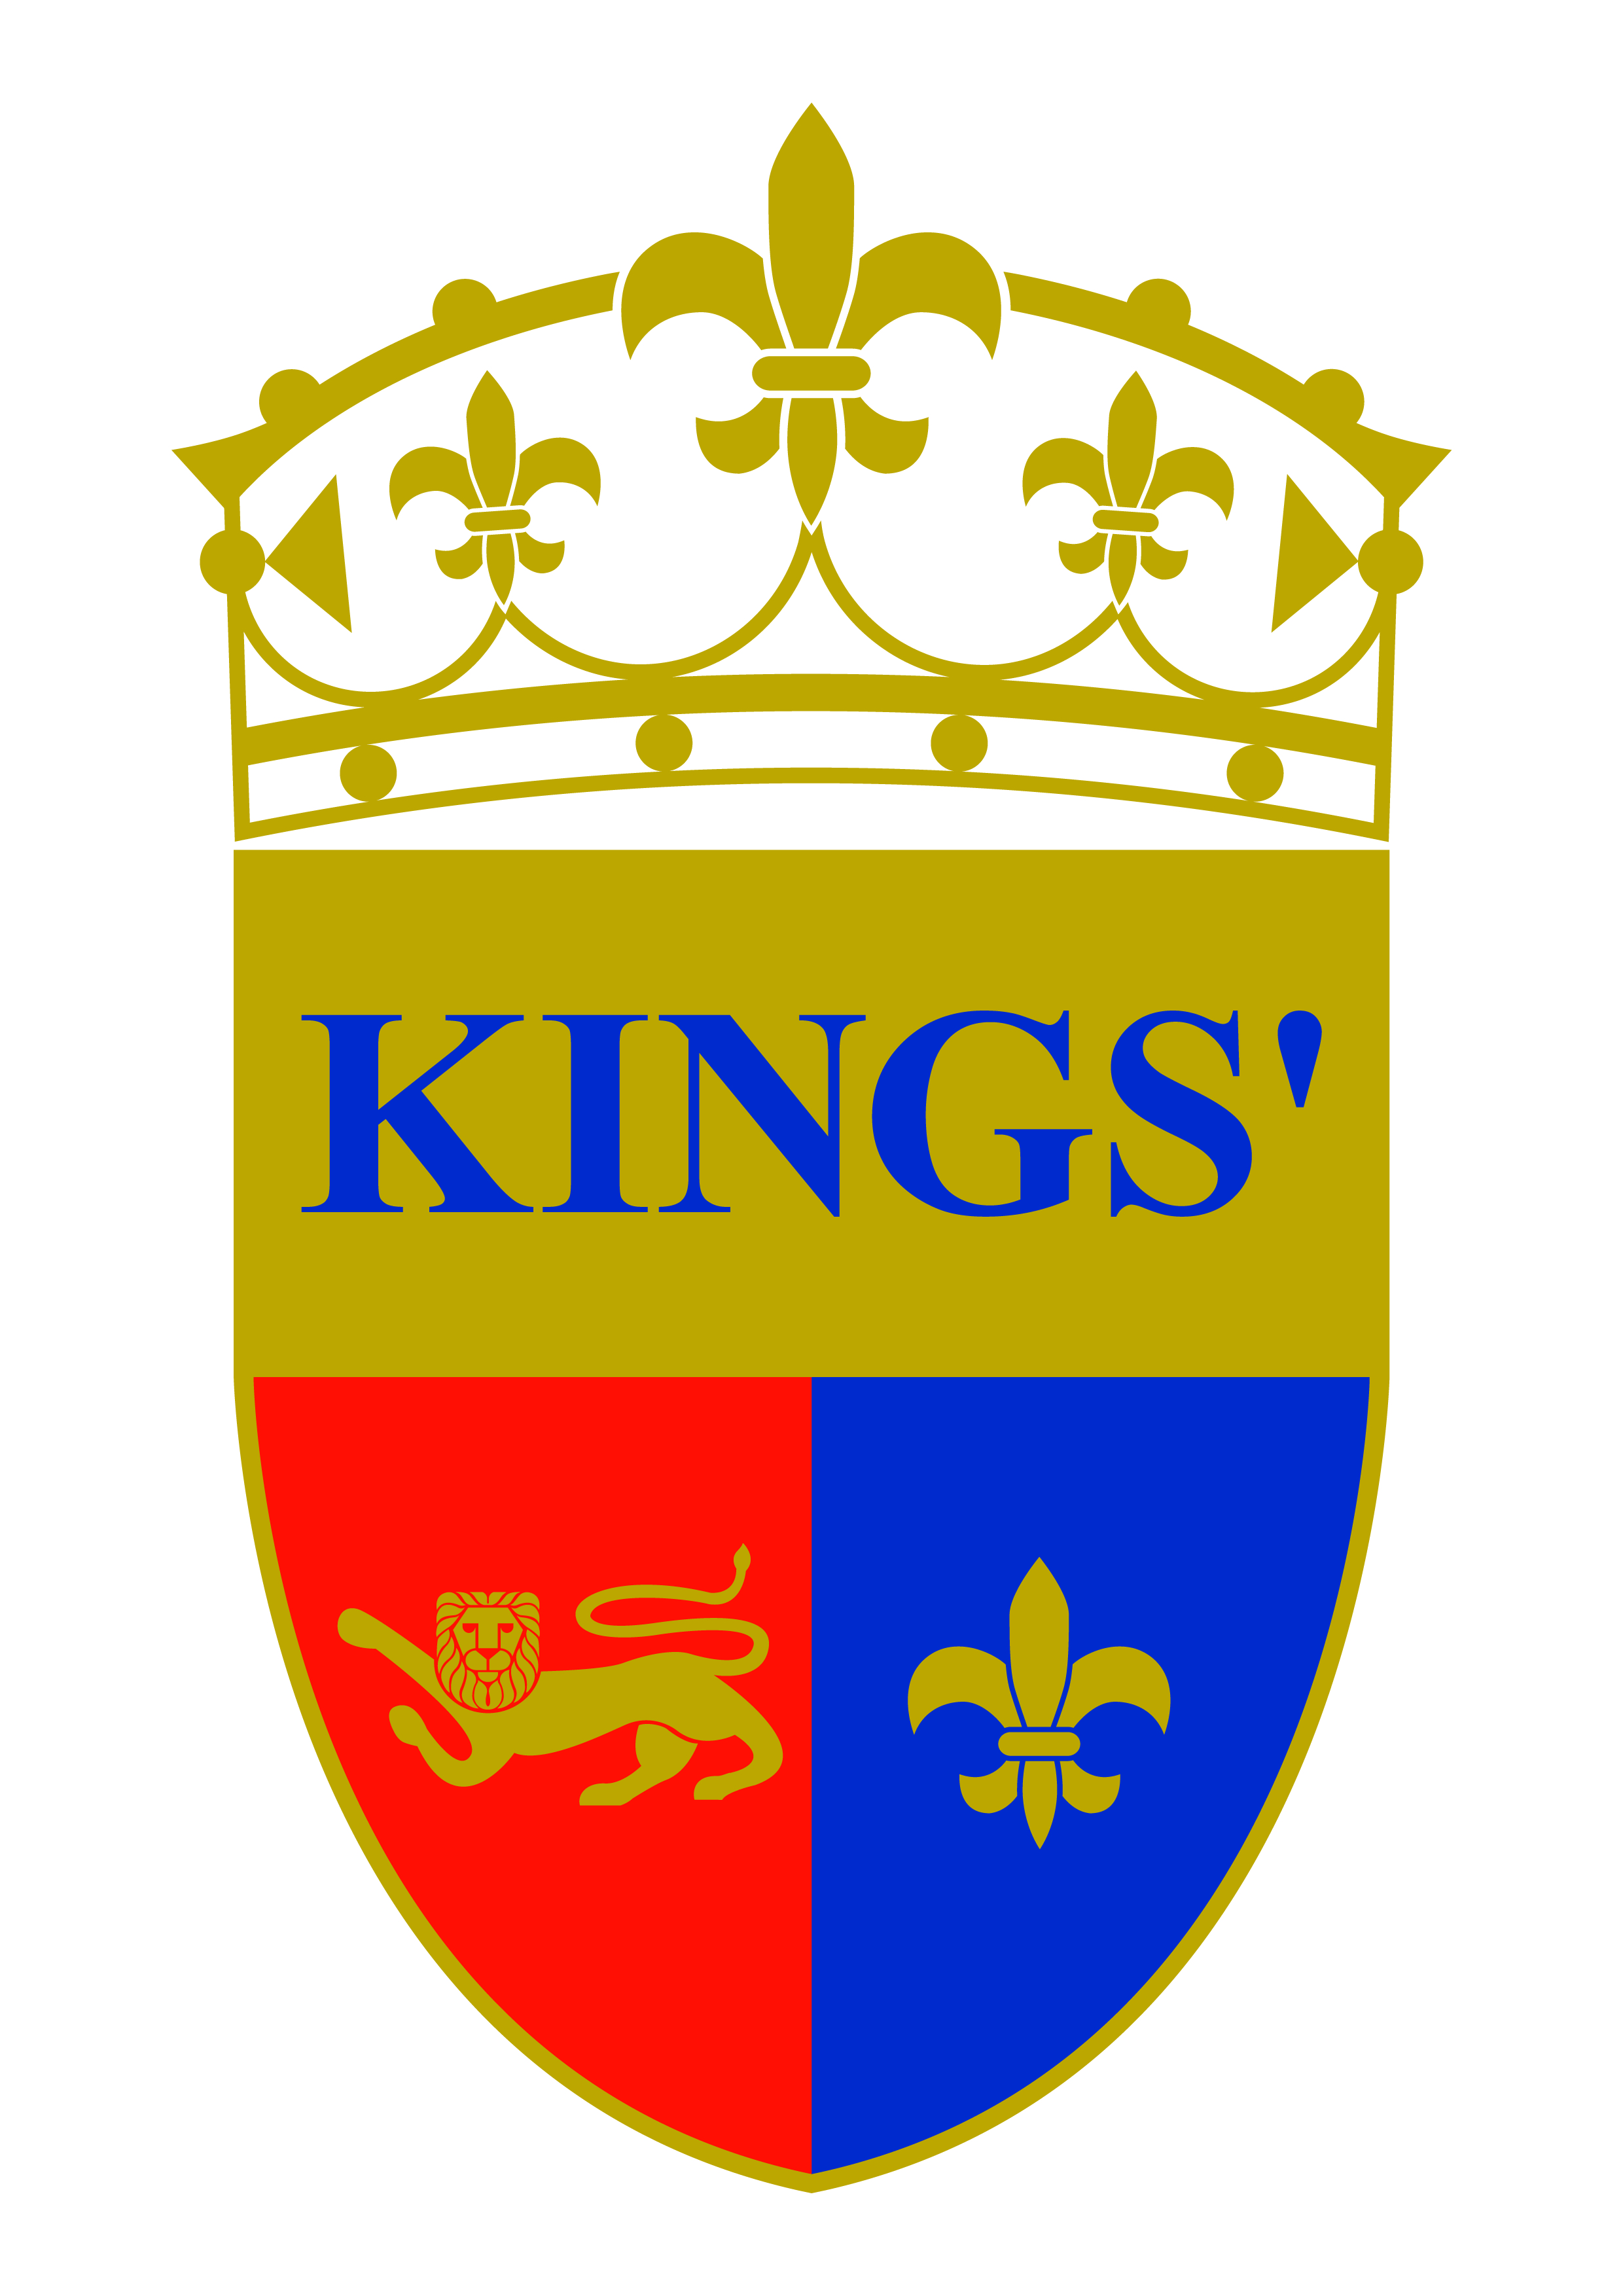

Kings’ School Al Barsha

Groundsman

Kings’ Education is a prestigious group offering an outstanding education for students from foundation through to secondary level. Kings' founding school is the only one in the Emirates to have achieved the rating of “outstanding” since the launch of inspections by the Dubai Schools Inspection Bureau. Kings' students achieve exceptionally high academic standards via creative, innovative approaches to teaching and learning; curriculum design and delivery that often break from tradition. We adopt forward thinking approaches that cater for all learning styles. All our schools have a British heritage and an international perspective where children become effective, enthusiastic and independent life-long learners who are able to adapt to the changes and challenges of a fast-moving, modern world.

We have a vacancy for a Groundsman for Kings’ School Al Barsha working as part of our dedicated facilities team. In addition to relevant experience in IT and data entry, we are looking for an individual who demonstrate integrity, is a team player and who has a keen eye for attention to detail.

Essential skills and qualifications:

- At least 2 years’ experience in the UAE
- Experience of landscaping, and minor maintenance including plumbing, carpentry and painting
- Good level of spoken English
- Excellent appearance and personal hygiene
- Ability to be positive, proactive and creative in finding new solutions
- Ability to deliver an outstanding service

Only candidates with relevant experience and qualifications should apply. The closing date for applications is 24th June 2016.

If you are interested in joining a dynamic, dedicated team at one of Dubai’s leading schools, please send your CV with photo and covering letter to
careers@kingsdubai.com

Further information on our schools can be found at
www.kingsdubai.com

