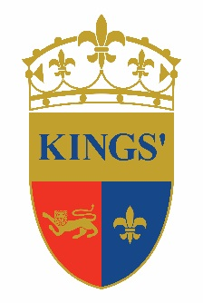
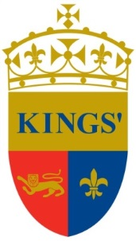

Kings’ School Al Barsha

PRIMARY COMPUTING TEACHER/DIGITAL COACH
Immediate Start

Kings’ Education is a group of premium schools, welcoming students from around the globe from age 3 to 18 years. The education we deliver in our schools combines a British-based curriculum with an international perspective, tailored to the needs of our community of young people growing up in Dubai today, whether expatriate or local. We foster ‘The Best by Every Child’ to effectively support all our students striving to reach their true potential.

Since 2004, Kings’ has grown from a few hundred to over 2,600 students in three campuses: Kings’ School Dubai, Kings’ School Al Barsha and Kings’ School Nad Al Sheba offering Foundation Stage, Primary and Secondary levels of education. All our schools have the same high standards and exceptional levels of student attainment and progress that have made Kings’ School Dubai the only school in Dubai to achieve an Outstanding rating from the Dubai Schools Inspection Bureau since inspections began.

We have an immediate vacancy for a suitably qualified Primary Computing Teach/Digital Coach at Kings’ School Al Barsha with at least 2 years’ experience, preferably within the UK or in English curriculum schools.

If you are interested in joining a dynamic, dedicated team at one of Dubai’s leading schools, please send your CV with photograph and letter of application to:
careers@kings-edu.com

General information about Kings’ School in Dubai can be located at
www.kings-edu.com

