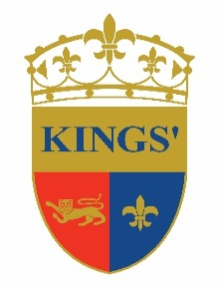

Kings’ Education

SECONDARY LEARNING SUPPORT ASSISTANT – PART TIME
Immediate Start

Kings’ Education is a group of premium schools, welcoming students from around the globe from age 3 to 18 years. The education we deliver in our schools combines a British-based curriculum with an international perspective, tailored to the needs of our community of young people growing up in Dubai today, whether expatriate or local. We foster ‘The Best by Every Child’ to effectively support all our students striving to reach their true potential.

Since 2004, Kings’ has grown from a few hundred to over 2,600 students in three campuses: Kings’ School Dubai, Kings’ School Al Barsha and Kings’ School Nad Al Sheba offering Foundation Stage, Primary and Secondary levels of education. All our schools have the same high standards and exceptional levels of student attainment and progress that have made Kings’ School Dubai the only school in Dubai to achieve an Outstanding rating from the Dubai Schools Inspection Bureau since inspections began.

We have a part time vacancy for a Secondary Learning Support Assistant at Kings’ School Al Barsha.

The successful candidate will have be educated to at least A level standard (preferably degree standard), have good communication skills, be able to use their own initiative, think on their feet and have a desire and willingness to learn.

If you are interested in joining a dynamic, dedicated team at one of Dubai’s leading school groups, please send your CV and photograph to careers@kings-edu.com

Candidates should be on their husband/father’s visa.

Further information on our schools can be found at www.kings-edu.com

